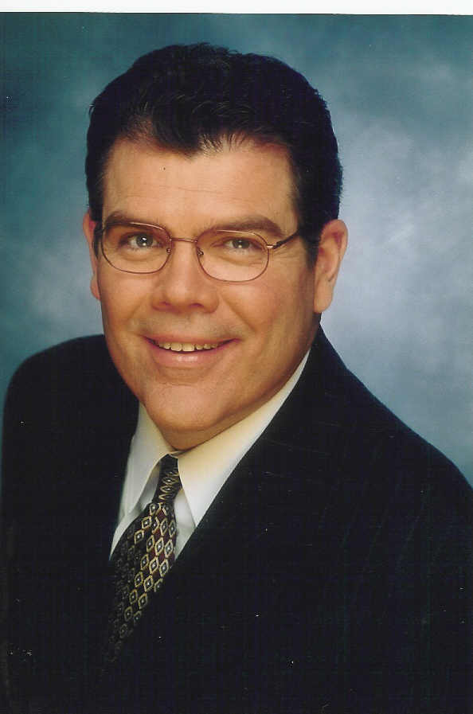

Thomas Bakewell CEO Counsel & Confidante

Advisor to CEO’s and Boards on strategy, governance and transformation.

Tom specializes in advising CEO’s and boards facing challenging situations, during times of transition and especially when it’s not business as usual.

His clients include the leaders of public and private companies, and prominent nonprofits. His industry experience is broad including higher education, healthcare, retail, banking, financial services, professional services, retirement communities, world relief organizations, and many more.

He has served on private company (retail & manufacturing) and nonprofit boards (education & health care) with annual revenues ranging from $40 to $800 million, and provided strategic, financial and legal counsel to public company CEO’s and Boards.

Tom is on faculty for the National Association of Corporate Directors (NACD) and a Board Leadership Fellow with the NACD. He writes and speaks on diverse governance topics including: strategy and governance, succeeding in the board room, handling conflicts of interest at the board level, building private company boards and strengthening shareholder relations, effective nonprofit governance and handling nonprofit crisis.

As an experienced director and executive, who is also a skilled attorney and CPA, Tom regularly provides unique insights and advice to his CEO and Board clients.

McGraw-Hill published Tom’s book Claiming Your Place at the Boardroom Table: The Essential Handbook for Excellence in Governance and Effective Directorship in late 2014.

Tom holds a JD from the University of Memphis, MBA from St. Louis U. and MS from the Harvard School of Public Health. His law and CPA licenses are current.

Tom previously served as both Senior Vice President Law & Government Affairs and Director of Financial Planning for The Daughters of Charity (now Ascension). He began his career in blue chip law and accounting firms, and clinic management.

Thomas Bakewell … “When it’s not business as usual”
669 Claymont Court Circle, Saint Louis MO 63011
Tom@ThomasBakewell.com
www.thomasbakewell.com
(314) 960-2326

